Capstone Project Proposal Report
(Individual Report)

Instructions:

This form is to be completed by each student doing Project registration to fulfill their senior design or capstone requirement. It must be completed and submitted to your Guide. Each student must complete this form individually.

This report is to be completed during the starting of the semester, while the project description report will be completed during end of the semester.

Guide Approval (initials/date):

CAP4001– Capstone Project Proposal Report

Student Name |  | Nandipati Lakshmi Narasimha Reddy
Student Register Number |  | 23BCB7272
Programme |  | B.Tech – Computer Science & Business Systems (CSBS)
Semester/Year |  | Semester 7 – FALL SEM 2026-27
Guide(s) |  | Priyanka Singh
Project Title |  | AI-Powered Enterprise Knowledge and Assistance Platform
Team Composition: Provide the information below for each member of the project team. Include all project team members, not just those in your discipline or those enrolled for Capstone project. Please also include yourself!

Reg. No | Name |  | Major | Specialization
23BCB7272 | Nandipati Lakshmi Narasimha Reddy |  | Computer Science | & Business Systems
23BCB7174 | Damarla Himanvi |  | Computer Science | & Business Systems
23BCB7270 | Sriram Reddy Mariyada |  | Computer Science | & Business Systems
23BCB7127 | Dheerendra Pratap Singh |  | Computer Science | & Business Systems

Project and Task Description: Provide a brief (one or two page) technical description of the design project and your specific tasks, as outlined below: (use a separate sheet)

- Provide a summary of the project, including a description of the project and its requirements, the purpose, specifications, and a summary of the approach. If this is a continuing project, you may use and/or edit the same project description.

- Describe the specific role and tasks that you individually will be completing as part of the design of the project. What specific deliverables will you produce?

- Discuss in detail the specific approach that will be used to complete your portion of the design.

- Describe the phases of the design process that will be incorporated and what work will be accomplished during those phases. (you may attach a Gantt Chart)

(a) Project and Task Description - Project Summary

Project Description
The proposed project, AI-Powered Enterprise Knowledge and Assistance Platform, is a secure, multi-tenant enterprise AI system designed to transform an organization's internal knowledge into an accessible and context-aware employee assistance platform.

Organizations generate large volumes of internal knowledge through employee handbooks, standard operating procedures, technical documentation, policies, security guidelines, project documents, and other organizational resources. However, this knowledge is often distributed across different sources, making it difficult for employees to locate relevant information quickly. New employees may require considerable time to become familiar with organizational processes, while existing employees may repeatedly seek information that has already been documented. This can lead to knowledge silos, repeated effort, increased onboarding time, and loss of organizational knowledge.

The proposed platform addresses this problem by combining enterprise knowledge management, Retrieval-Augmented Generation (RAG), role-based access control, and an AI employee copilot. Employees will be able to interact with the system using natural-language questions and receive responses grounded in their organization's authorized knowledge.
Unlike a chatbot designed for a single organization, the proposed system will follow a multi-tenant SaaS architecture, allowing multiple organizations to use a common AI platform while maintaining logical isolation of their users, documents, vector data, conversations, and configuration.
The platform will provide three major user experiences:
- Platform Administrator - manages organizations and monitors platform-level information.
- Organization Administrator - manages organization-specific knowledge, users, roles, and configuration.
- Employee / End User - interacts with the AI assistant, searches organizational knowledge, and receives guided workflows.
These three experiences form the core product structure defined in the project's UI/UX workflow specification.

Functional Requirements
The proposed system will provide the following core functionality:
1. Organization and Tenant Management
- Creation and management of organizations.
- Association of users with their respective organizations.
- Maintenance of organization-specific configuration.
- Logical isolation of organizational data.
2. Authentication and RBAC
- User authentication.
- Role assignment and management.
- Role-aware access to application functionality.
- Role-aware knowledge retrieval.
3. Knowledge Management
- Upload of enterprise documents.
- Support for documents such as PDF, DOCX, TXT, CSV and Markdown files.
- Document search and management.
- Document metadata management.
- Document processing status.
The workflow specification specifically identifies document upload, text extraction, cleaning, chunking, embedding generation and vector indexing as the knowledge-processing workflow.
4. AI Employee Copilot
- Natural-language question answering.
- Context-aware responses.
- Source citations.
- Relevant source documents.
- Related questions where applicable.
- User feedback.
5. Workflow Guidance
Process-oriented questions such as:
"How do I deploy a project?"
will be handled as actionable workflows containing relevant steps, required tools or access, and supporting source information rather than only a conventional paragraph response.
6. Enterprise Search
- Search organizational documents.
- Search relevant people or teams where supported.
- Display relevant excerpts and source documents.
7. Feedback and Evaluation
- Helpful/not-helpful feedback.
- Incorrect or outdated information reporting.
- Missing-information feedback.
- Evaluation of retrieval and response quality.

Purpose of the Project
The primary purpose of the project is to develop a reusable enterprise AI platform that can:
- Centralize organization-specific knowledge.
- Provide employees with natural-language access to organizational information.
- Reduce repetitive questions and improve knowledge accessibility.
- Support employee onboarding and day-to-day decision making.
- Provide source-cited responses grounded in organizational documents.
- Provide actionable, step-by-step workflow guidance.
- Enforce role-based access to organizational information.
- Maintain strict separation between different organizations.
- Allow administrators to manage and improve the organization's knowledge base.
The system therefore aims to provide more than conversational interaction; it aims to act as an intelligent knowledge layer between employees and organizational information.

Technical Specifications
Layer | Technology
Frontend | React
Backend | Python + FastAPI
Database | PostgreSQL
Vector Store | FAISS
LLM | Qwen3-8B
LLM Runtime | Ollama
AI Architecture | Retrieval-Augmented Generation
Embedding Layer | Embedding model for semantic document retrieval
The current technical design uses a common base LLM with organization-specific knowledge supplied through RAG rather than training a separate LLM for every organization.

System Approach
The proposed system will follow an end-to-end RAG-based architecture.
Knowledge Ingestion
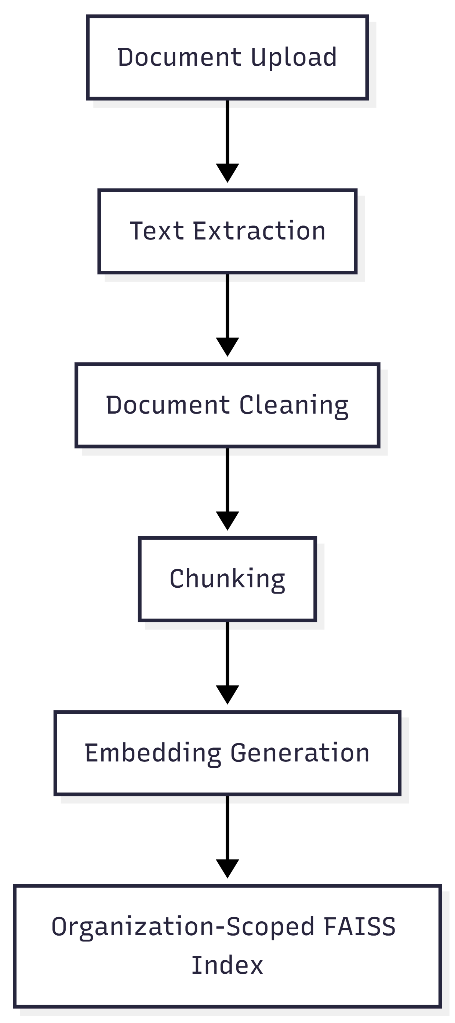

Employee Query
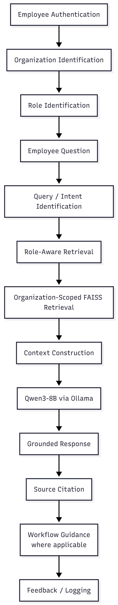
Multi-Tenant Architecture
Tenant isolation will be treated as a core security requirement.
Each organization will maintain logically isolated:
- Users
- Roles
- Documents
- Vector data
- Conversations
- AI configuration

For example:
Organization A
- Users
- Documents
- Vector Index
- Conversations
- Configuration
Organization B
- Users
- Documents
- Vector Index
- Conversations
- Configuration
Organization A must never retrieve Organization B's knowledge.
Furthermore, role-based authorization must be applied before knowledge retrieval so that an employee cannot retrieve restricted information merely because the document exists within the organization's knowledge base.

Proposed Objectives
Objective 1
To design and develop a multi-tenant enterprise AI platform that allows multiple organizations to use a common AI capability while maintaining logical data isolation.
Objective 2
To develop a document ingestion and knowledge-processing pipeline that converts enterprise documents into searchable, organization-specific vector representations.
Objective 3
To implement a Retrieval-Augmented Generation pipeline that retrieves relevant organizational knowledge and provides grounded responses using Qwen3-8B.
Objective 4
To implement role-based and organization-aware retrieval so that AI responses are generated only from information accessible to the authenticated user.
Objective 5
To provide employees with source-cited and actionable AI assistance, including step-by-step workflow guidance for process-oriented queries.
Objective 6
To develop separate interfaces for Platform Administrators, Organization Administrators, and Employees.
Objective 7
To evaluate the developed system with respect to retrieval relevance, response grounding, access control, tenant isolation, and functional correctness.

Proposed Hypothesis
If organization-specific enterprise knowledge is processed through a role-aware Retrieval-Augmented Generation pipeline and provided as grounded context to a locally hosted Qwen3-8B model, then employees will be able to obtain relevant, source-grounded and actionable responses while maintaining organization-level and role-level information isolation.

Problem Survey / Existing Approaches
Existing Enterprise Knowledge Repositories
Traditional enterprise knowledge systems provide centralized storage for policies, documents and procedures. However, users may still need to manually search through documents to locate the information they require.
Enterprise Search
Search systems improve information discovery through keyword or semantic retrieval, but search results still require users to interpret the retrieved information themselves.
Conventional Chatbots
Chatbots provide conversational interfaces but may not have access to organization-specific information or mechanisms for reliable source grounding.
General-Purpose LLMs
General-purpose LLMs can generate fluent responses but do not inherently possess an organization's private knowledge and may produce unsupported information when the required context is unavailable.
Retrieval-Augmented Generation
RAG addresses this limitation by retrieving relevant information from an external knowledge base and supplying it to the LLM as contextual information before generating the response.
The proposed system uses this approach rather than attempting to train a separate LLM for every organization.
Identified Gap
The project does not claim that RAG, LLMs, chatbots, or enterprise search are individually novel.
Instead, the proposed work focuses on integrating these capabilities into a reusable multi-tenant enterprise platform that combines:
- Organization-specific knowledge
- Tenant isolation
- Role-aware retrieval
- RAG-based question answering
- Source citations
- Workflow guidance
- Employee assistance
- Administrative knowledge management

(b) Individual Role and Tasks
Role: Data Refinement, Data Handling and AI/RAG Engineer
I will primarily be responsible for the data-processing and AI/RAG components of the project. My role will focus on preparing organizational knowledge for retrieval, maintaining the data-processing pipeline, and contributing to the integration and evaluation of the RAG and language-model components.
Individual Responsibilities
- Analyze and prepare enterprise knowledge documents for ingestion.
- Develop data-cleaning and refinement processes.
- Handle document extraction and preprocessing.
- Implement or contribute to document chunking.
- Prepare document metadata required for retrieval and access control.
- Contribute to embedding generation.
- Develop organization-scoped FAISS indexing components.
- Implement retrieval mechanisms for relevant knowledge chunks.
- Integrate Qwen3-8B through Ollama.
- Contribute to context construction and prompt preparation.
- Evaluate retrieved context and generated responses.
- Work with the other team members to integrate the RAG/model layer into the Platform, Organization and Chat domains.

Specific Deliverables
- Data preprocessing and refinement pipeline.
- Document ingestion components.
- Chunking and embedding preparation.
- Organization-scoped vector indexing components.
- RAG retrieval components.
- Qwen3-8B/Ollama integration.
- AI/RAG testing and evaluation results.
- Technical documentation for the data and RAG components.

(c) Specific Approach
The work will begin by analyzing the structure and characteristics of the enterprise documents that form the knowledge base. Documents will be extracted and cleaned to remove irrelevant formatting and inconsistencies while retaining information necessary for retrieval.
The processed content will be divided into meaningful chunks so that relevant portions can be retrieved efficiently. Appropriate metadata will be associated with the chunks to support organization and role-aware retrieval.
The resulting chunks will be converted into embeddings and stored in organization-scoped FAISS indexes. The retrieval mechanism will identify relevant chunks based on the semantic relationship between the user's query and the indexed knowledge.
The retrieved information will then be passed as contextual information to the Qwen3-8B model running through Ollama. The generated response will be evaluated for relevance, grounding and consistency with the retrieved organizational knowledge.
Special attention will be given to ensuring that the retrieval layer respects organization and access boundaries. The developed components will be integrated with the backend services developed by other team members.

(d) Design Phases
Phase 1 - Problem Identification and Requirement Analysis
Duration: August 2026
Activities:
- Analyze the enterprise knowledge-access problem.
- Study existing enterprise AI and RAG approaches.
- Identify functional and non-functional requirements.
- Define user roles.
- Define multi-tenant requirements.
- Finalize the MVP scope.
- Define evaluation requirements.
Deliverables:
- Problem statement
- Requirement specification
- Literature/problem survey
- Initial product scope

Phase 2 - System Architecture and Design
Duration: August - September 2026
Activities:
- Design overall architecture.
- Design multi-tenant architecture.
- Define database schema.
- Define API architecture.
- Design document-processing pipeline.
- Design RAG architecture.
- Design role and authorization model.
- Finalize UI/UX workflows.
Deliverables:
- System architecture
- Database design
- API design
- RAG architecture
- UI/UX designs

Phase 3 - Core AI and Knowledge Pipeline
Duration: August - September 2026
Activities:
- Document extraction.
- Data cleaning.
- Chunking.
- Embedding generation.
- FAISS indexing.
- Retrieval implementation.
- Qwen3-8B/Ollama integration.
- Context construction.
- Source citation.

Phase 4 - Domain Development
Duration: September - October 2026
Parallel development of:
Platform Domain
- Organization creation
- Organization management
- Platform-level views
Organization Domain
- Organization dashboard
- Knowledge Base
- Document processing
- Users & Roles
- AI configuration where applicable
Chat Domain
- Employee AI Home
- AI Chat
- Workflow responses
- Search
- Feedback

Phase 5 - Integration
Duration: October 2026
Activities:
- Integrate all three domains.
- Integrate frontend and backend.
- Connect document processing to RAG.
- Connect tenant context to retrieval.
- Integrate RBAC.
- Integrate source citations.
- Integrate feedback.
- Perform end-to-end testing.

Phase 6 - Testing and Evaluation
Duration: October 2026
Testing will cover:
- Functional correctness
- Retrieval relevance
- Response quality
- Source grounding
- RBAC
- Tenant isolation
- Document processing
- API functionality
- UI functionality
- End-to-end workflows

Phase 7 - Feature Completion and Stabilization
Target: October 31, 2026
The core system will be feature-complete by the team's internal target of October 31, leaving November for:
- Bug fixing
- Performance improvement
- Evaluation
- Documentation
- Final demonstration preparation
- Report preparation

Phase 8 - Final Documentation and Presentation
November 2026
- Final evaluation
- Project report
- Poster
- Final presentation
- Demonstration
- Supporting material
Gantt Chart
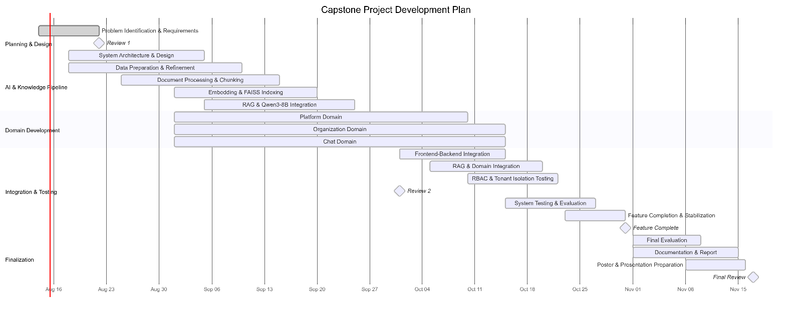

Outcome Matrix: Describe your plan to demonstrate each of the outcomes below.

Outcomes: | Plan for demonstrating outcome:
a) an ability to apply knowledge of mathematics, science, and engineering | The project applies concepts from artificial intelligence, information retrieval, database systems, software engineering, vector-based similarity search and system architecture. Embeddings, similarity-based retrieval and information-processing techniques will be applied in the RAG pipeline.
c) an ability to design a system, component, or process to meet desired needs within realistic constraints such as economic, environmental, social, political, ethical, health and safety, manufacturability, and sustainability | The team will design a multi-tenant enterprise AI platform considering computational resources, development time, security, privacy, scalability, usability, maintainability and cost.
d) an ability to function on multidisciplinary teams | The project requires coordinated work across AI/RAG, data processing, frontend development, backend development, database systems, security, testing and product design. Team members will independently develop domains while integrating them into a single system.
e) an ability to identify, formulate, and solve engineering problems | The team identifies fragmented enterprise knowledge, repeated employee queries and difficult information access as engineering problems and addresses them using RAG, role-aware retrieval, tenant isolation and workflow guidance.
g) an ability to communicate effectively
  The team will communicate requirements, design decisions, implementation progress and evaluation results through technical documentation, architecture diagrams, review presentations, demonstrations, the final report and project poster.
k) an ability to use the techniques, skills, and modern engineering tools necessary for engineering practice | The project uses React, Python, FastAPI, PostgreSQL, FAISS, Qwen3-8B, Ollama, embeddings, API development, database design, software testing, version control and RAG development techniques.

Realistic Constraints:
Discuss on the Realistic Constraints taken in to account for the Project:
Computational Constraints
The Qwen3-8B model will be executed locally through Ollama. Local inference may impose computational and memory requirements and may affect response latency depending on available hardware.
Time Constraints
The project must be developed within the academic capstone schedule. Therefore, we, the team will prioritize the core MVP before implementing stretch features.
Security and Privacy Constraints
Enterprise knowledge may contain restricted information. The system must therefore enforce authentication, role-based authorization and organization-level isolation before retrieval.
Data Constraints
The quality of AI responses will depend on the quality, completeness and structure of the documents supplied to the knowledge base.
Scalability Constraints
The capstone implementation is a prototype, but the architecture will be designed to support multiple organizations with logically isolated knowledge bases.
Usability Constraints
The system should allow employees to ask natural-language questions without requiring specialized knowledge of AI or information retrieval.

Engineering Standards:
Discuss the Engineering Standards that will be followed and maintained in the Project:
The project will refer to established engineering standards and security frameworks relevant to developing a secure and reliable enterprise AI platform.
- IEEE 29148: Requirements will be systematically identified, documented, and traced to system components and testing.
- OWASP ASVS: Relevant application-security practices will guide authentication, authorization, input validation, and secure API handling.
- OWASP Top 10: Common web-security risks such as broken access control, injection, and security misconfiguration will be considered.
- Secure Multi-Tenant Design: Organization and role-based access controls will prevent unauthorized and cross-tenant data retrieval.
- Software Engineering Practices: Modular design, version control, documentation, testing, and incremental integration will be followed.
- AI/RAG Practices: The RAG pipeline will separate document processing, retrieval, context construction, and response generation, with source grounding where applicable.

